H 3995 Road 1991  
Dumistan 1019, Bahrain  
Tel: 35158839  
E-mail: [mmakkif77@gmail.com](mailto:mmakkif77@gmail.com)

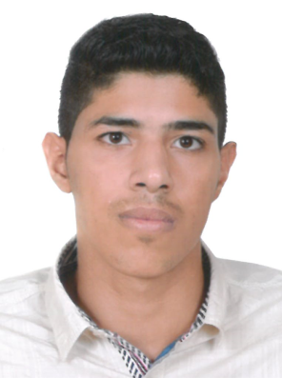  
**PERSONAL INFORMATION:**

Name: Mahdi Makki Fadhel Hasan.  
Date of Birth: 4/4/2000.  
Gender: Male  
Marital Status: single  
Nationality: Bahraini

Tel:35158839

Personal number: 000400920

**EDUCATION:**  
**sh. Isa bin Ali Al-Khlifa commercial Secondary school**  2015- 2018  
  
**EXPERIENCE:**

**Papa johns**  
Customer service

And kitchen worker

**SKILLS:**

**o** I have driving License private.

**o**Can work both independently and in a team environment

**Computer Knowledge**(windows, MsOffice, Photoshop, Programs)  
I’m fast in typing , also very well in preparing the computer like, formatting , maintenance, making websites and everything related to it. However, Design

advertisements, panars, proshors, Backgrounds, logo)

**Language:**

**o Fluent in writing and speaking in Arabic.**

**o Good in writing and speaking in English**  
I am studying at the Thales Institute , DIRECT ENGLISH